35.52: There is just one half-cycle phase change upon reflection, so for constructive interference: 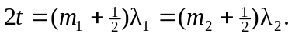 But the two different wavelengths differ by just one 